Chapter 16, Problem 88.

Develop the state equations for the circuit shown in Fig. 16.102.

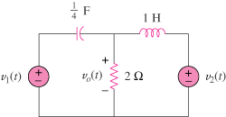

Figure 16.102
For Prob. 16.88.

